Novu Coffee Website Development Document
Created by: Eduard Xander M. Mariquita

Prototype Design
These sections will describe the website design and considerations that will be carried towards the finalized mock-up.

Prototype Wireframe
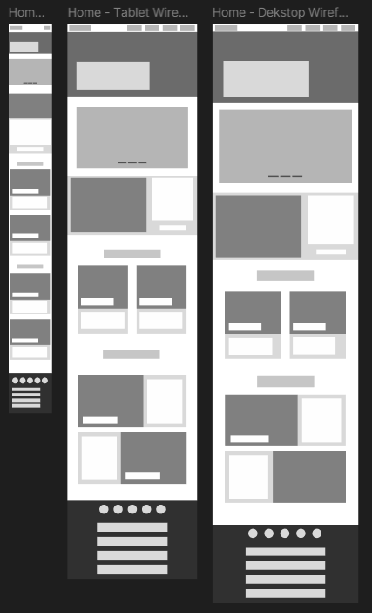
Home Page
The home page is the first to be designed and as such served as the basis in which the rest of the webpage’s design and grid. The home page is designed to introduce the café’s brand identity and serves as the first impression to our interested users.

Key Elements
- Hero Section
- Navigation Bar
- Call to Action Buttons
- Current Events (Carousel Slide)
- Seasonal / Featured Products
- Footer with Essential Links

Design Decisions
A clean and minimal was chosen to reflect a modern café aesthetic. The hero section uses strong and bold visuals to draw in the user’s attention while the carousel slide and banner serve to inform them of the current events.

User Experience Considerations
The layout prioritizes clarity and ease of use, ensuring users can quickly understand the brand and access important pages without hassle or confusion.
Products Page
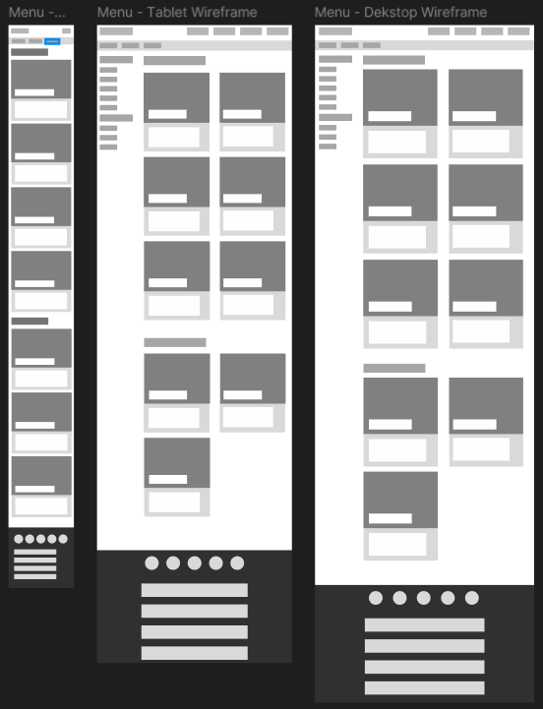
The products page showcases the café’s menu and allows users to browse available drinks and food easily.

Key Elements
- Product Cards with Image, Name, and Product Description
- Top Bar categorizes products by Seasonal / Promotional Products, Drinks, and Foods.
- Simple Grid Layout

Design Decisions
The products page showcases the café’s menu and allows users to browse available drinks easily.

User Experience Considerations
Users can quickly compare items without being overwhelmed by excessive information. The price was chosen not to be displayed so users can decide based on what they want and not how much that product costs in hindsight. The price will be displayed in the product information section.

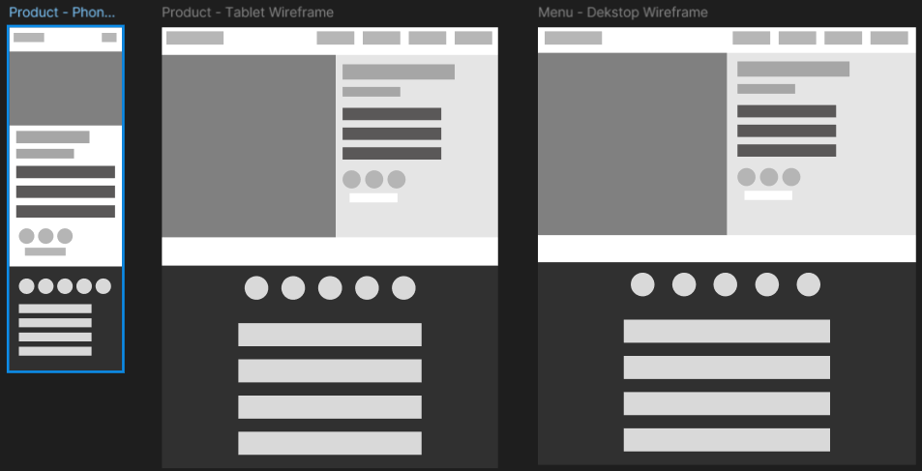
Product Info Page
This page provides detailed information about a selected product to help users understand ingredients and pricing.

Key Elements
- Large Product Image
- Product Description
- Price and Size Option
- Nutritional Facts
- Ingredients

Design Decisions
The layout focuses on a single product to avoid distractions. Information is presented in a clear hierarchy, with the product name and description given priority.

User Experience Considerations
The layout focuses on a single product to avoid distractions. Information is presented in a clear hierarchy, with the product name and description given priority.

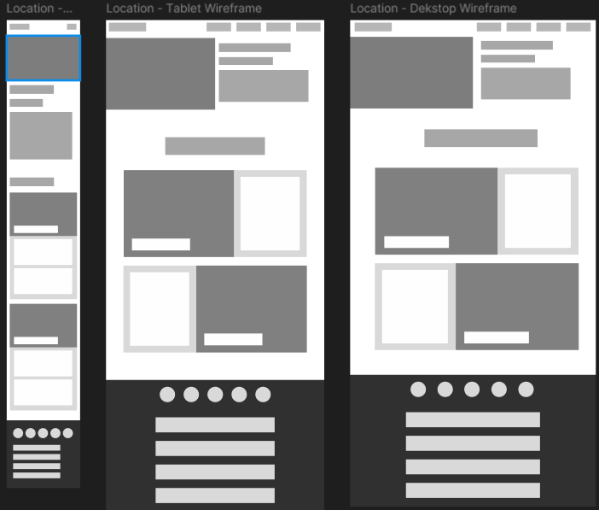
Locations Page
The locations page helps users find café branches and essential visit information.

Key Elements
- Location Cards
- Branch Name, Address, and Contact Number
- Opening Hours

Design Decisions
The locations page helps users find café branches and essential visit information.

User Experience Considerations
Cards were used to separate each location, making the information easy to scan and visually consistent.

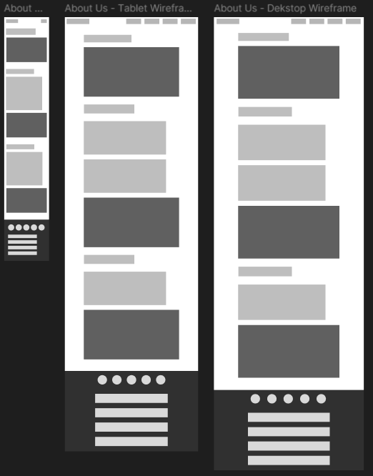
About Us Page
The about page communicates the café’s identity, values, and story to build trust and brand personality.

Key Elements
- Brand Story Section
- Mission or Values Statement
- Supporting Images

Design Decisions
The about page communicates the café’s identity, values, and story to build trust and brand personality.

User Experience Considerations
Content is broken into short sections to maintain readability and avoid overwhelming the user.

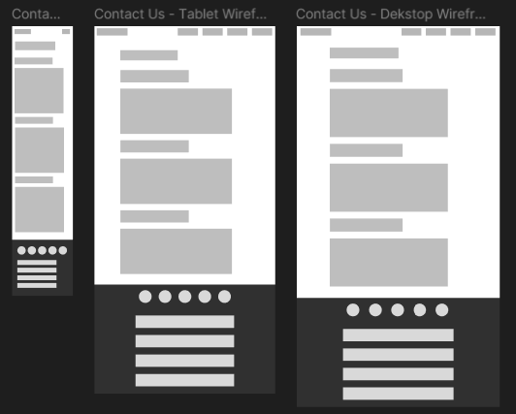
Contact Us Page
The contact page allows users to easily get in touch with the café for enquiries or feedback.

Key Elements
- Media Contacts

Design Decisions
A simple form layout was chosen to reduce friction and encourage users to submit enquiries.

User Experience Considerations
A simple form layout was chosen to reduce friction and encourage users to submit enquiries.

Prototype Mock-up (Home Page)
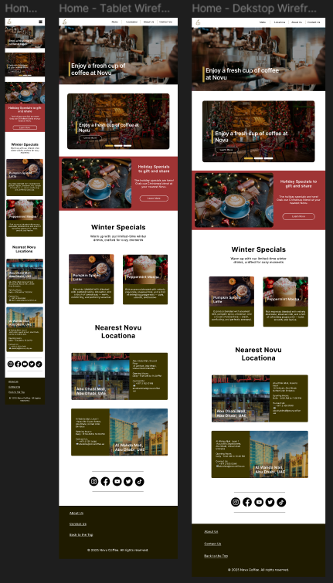
This section presents the mock-up design that will be used for the creation of the website, some details / sizes may or may not be altered in the final product due to lack of perspective in Figma.
Final Artifact
Technical Applications

Final Artifact Screenshots
Inspirations:
- Starbucks - https://www.starbucks.com/
- Tim Hortons - https://www.timhortons.com/

